**THE SAFETY HOUSE COMMUNITY VOLUNTEER**

**CHILD SAFETY PROGRAM**

**Everything you need to know about how to start up a Safety House program in your local community**

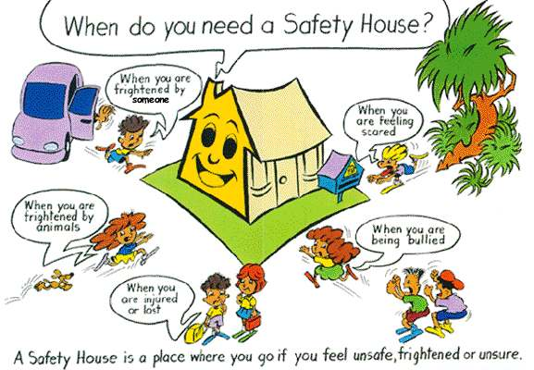

**How to start up a local Safety House program**

1. The Safety House program is a community driven "Good Neighbour" child safety initiative run locally by a group of interested and caring people in the community who want to provide support and personal safety for any young children in need of help.

Coffee Cup

1. This group of people, known as a Safety House Committee, are usually part of a school P&C or P&F Association, part of a local community group or part of a formal body such as a Council or some other organisation. This Committee works closely with local schools, parents and the community.
2. The first step is that two or three people decide that they want to provide local children with safe places to seek help between home and school if they ever need it.
3. This small group then contacts parents and local residents to see if they would be willing to support setting up a Safety House program in the local area. A notice included in the school newsletter, website, Facebook©, Twitter©, social media and the local community newspaper can be good ways to contact everyone.



1. If there is enough support, a meeting can be called to talk through the idea and have any questions answered. The Safety House WA Head Office will assist by providing information and brochures and someone from Safety House to attend the meeting, talk about Safety House and answer any questions about the idea.
2. Anyone in the local community who is interested in the program may choose to apply to become a registered Safety House. A yellow letterbox sign lets children know it is somewhere safe where they can seek help. Some people may also be interested in joining the Safety House Committee.



1. [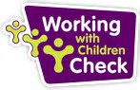](http://www.bing.com/images/search?q=working+with+children+logo&id=DAC008908A1AD10CE6606693E42DF86B77D97590&FORM=IQFRBA)In every registered Safety House at least one adult must hold a valid Working with Children Card and be willing to have a Police Check. This is vitally important as any parent wants to know that if their child ever needed to seek help, the person at the Safety House had been fully approved and Police checked.

**How to run a local Safety House program**



1. Once the new Safety House Committee has been formed and approved they can start promoting and building the program. The Committee Members will be looking for people to become Safety Houses, particularly on busy or difficult travel routes to the local school. There is no correct number of Safety Houses in a community, as a lot will depend on population density and student transit routes to the school.
2. The Committee will choose one person, or it can be a small group of people, to be the Group Coordinator and the Safety House WA Head Office will do everything possible to help with any issues and to ensure that there is not too great a workload on the Committee Members. There is a minimum of paperwork and the Safety House WA Head Office is always there to help any Group Coordinator or Committee Member if they are having any challenges.
3. It is important that annually during Term 1, the Committee needs to make some personal contact with each Safety House in their area. This can be done by email, social media, phone or in person. This is needed to make sure the same people are still living at the address and nothing has changed that could make a difference to them being a registered Safety House. A report is then emailed back to the Safety House WA Head Office with any changes. In Terms 2, 3 and 4 only a visual check is needed on all Safety Houses in the group. This ensures that yellow letterbox plates are visible and undamaged and looks out for any changes or other factors that might make the property no longer suitable to be a registered Safety House.
4. It is important that local Primary Schools and their P&C or P&F Associations promote the Safety House message of child safety through their school community as much as possible. This can be through websites, Facebook©, Twitter©, social media, newsletters, posters, notice boards, fund raisers, class activities and projects, school assembly items, etc. There are also special Safety House events such as Yellow Day and the annual Safety House WA Art Competition that bring the personal safety message to life for primary school children.
5. All Safety House Group Coordinators and Committee members are fully covered by the Association’s Public Liability and Volunteer Personal Injury insurances whilst they are doing Safety House Committee work. Individual Safety Houses are not covered by Safety House WA but of course many should already have adequate personal and property insurance cover.

**How to decide who can be a Safety House**



1. A Safety Householder must be ready and willing to help any child who might seek help at their door. They need to be understanding and caring and be ready to use their telephone to contact the child’s parents, school and if necessary, the Police.
2. At least one adult in every Safety House must hold a valid Working with Children Card. Other adults in the residence likely to assist a child must also hold a valid WWC Card. Everyone aged 14 years and over must give their informed consent to be police checked if required.

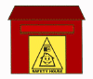

1. Every Safety Householder must agree to abide by the principles of Safety House WA including that they agree to clearly display a Safety House Letterbox Plate and advise their local Safety House Group Coordinator of any change in personal circumstances that might make them no longer able to be a Safety House.
2. Some adult person should generally be at home during children’s school travel times. This is generally between 8am and 9am and also between 3pm and 4pm. Our suggested broad guideline is that an adult is at home at these times at least two and a half days out of five on a regular basis as this ensures that if a child knocks on that Safety House door needing help they have a better than even chance of finding someone at home. If there is any doubt about an applicant’s times of availability, Safety House WA will be able to discuss and offer advice to the Committee.



1. The house must have easy street access to the front door. The letterbox with the Safety House plate must be easily visible from the street. Any child seeking help must be able to get to the front door easily and not have to go round the rear or down the side of the house to find the entrance and get help.
2. Houses with high fences and gates or with entrances heavily screened by structures or trees are not acceptable as Safety Houses as these could present an ambush spot danger to a child being followed by an undesirable person when they are out of sight of the street.
3. If there is a dog on the premises the dog should be secured and not be able to wander around the front yard. If a child seeks help at the Safety House there should not be any chance that a dog would threaten or scare that child away from going to the front door.

**What is the cost to run a local Safety House program?**

**[](http://www.bing.com/images/search?q=working+with+children+logo&id=DAC008908A1AD10CE6606693E42DF86B77D97590&FORM=IQFRBA)**

1. Regrettably Safety House WA Inc is not able to pay the WA Government application fee charge for the 3 year Working with Children Card as this must done direct by the applicant in through Australia Post. However, with a WWC Card application form authorised and signed by Safety House WA the community volunteer application fee is only $11.00 rather than the current $87.00 working person fee, a saving of $76.00 for an identical 3 year WWC Card. In cases of proven hardship, Safety House WA may financially assist applicants.
2. There is no cost for any WA Police checking as this is fully paid by Safety House WA.



1. There is an annual Safety House Committee affiliation fee of $130.00 including GST which provides free insurance cover for all Committee Members whilst doing Safety House WA work and full support and advice from the Safety House Office. Individual householders should have their own residential insurance cover. The annual fee also gives a Safety House Committee free Safety House letterbox sign plates, posters, balloons, flyers and brochures as part of their annual membership. In the first year of any new Safety House Committee the affiliation fee is waived.

Waving Exclamation Mark

1. Many Safety House Committees have successfully asked their local Council Community Safety Department to support them in payment of their annual Safety House affiliation fee. We would encourage your Committee to contact your local Council about this and we would be happy to provide a formal tax invoice and a letter of support as part of this application.
2. There are no other financial costs involved in running a Safety House program and we always try to satisfy any material or resource needs at no cost to the group.

**Who supports the Safety House program in WA?**

The Safety House WA program receives limited non-financial support direct from the WA Department of Education and is grateful to a number of City Councils for community funding grants to school Safety House programs in their local areas. Safety House WA Inc. relies upon annual affiliation fees income received from Safety House Committees and works hard to obtain support from some external commercial and organisational sources to maintain our healthy financial situation.

**Do you have any questions or comments you would like answered about the Safety House program in WA?**

You can always ask the Safety House WA Head Office about any queries you might have and we welcome any comments or suggestions you might have about how the Safety House community child safety program functions. Email communication is our preferred method of communication as the Safety House WA Head Office may be unattended on some days due to school visits and meetings.

**SAFETY HOUSE WA HEAD OFFICE**

**EMAIL: safety@safetyhousewa.org.au**

**VOICEMAIL: (08) 6142 8579**

If you are ever faced with doubts about the suitability of a particular Safety House applicant or the accessibility and suitability of a particular residence as a new Safety House we are always happy to discuss the details of the situation with you and offer advice based on our experience from many local Safety House groups.